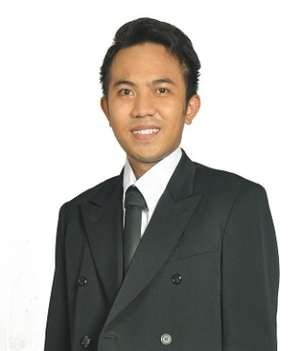

**CURRICULUM VITAE**

Full Name : Dedi Arief Wibisono

Place/ Date of Birth : Denpasar/ December 15th 1991

Marriage Status : Single

E-mail : dedi.wibisono17@gmail.com

Address : Taman Setiabudi E/7, South Jakarta

Phone : 085 737 361 067

Hobbies : Play PES 2016, Basketball

# SUMMARY

2 Year Experience for HTML5, CSS3, and JavaScript

2 Year Experience for Framework Design (Bootstrap)

1 Year Experience Database MySQL

1 Year Experience for CodeIgniter

1 Year Experience for Design Banner (Tools: Photoshop)

# WORK EXPERIENCE

**PT PopBox Asia**

Period­­­­­ : March 2016 - Present

Type : Shipping Product

Position : Front End Developer

Responsibility :

1. Create Wireframe (Tools: Balsamiq or Wireframe Sketcher)
2. Design Banner (Optional)
3. Re-Design Popbox Page
4. Create a new page for merchant

**PT Rakuten Belanja Online**

Period­­­­­ : September 2015-February 2016

Type : Web Commerce

Position : Creative Web Design

Responsibility :

1. Create New Event Page.
2. Update Product.
3. Provide the product to expose.
4. Sending Newsletter to Rakuten’s Member Email.
5. A/B testing for Newsletter.
6. Analytics Site Catalyst by Adobe Omniture
7. Create a Banner for our Merchant and our Event (Optional)

**PT Jogja Medianet**

Period : August 2013-September 2013

Type : ISP (Internet Service Provider)

Position : Web Design

Responsibility :

1. Create a design requirement for visualization of FTTH (Fiber To The Home)
2. Analyze the requirement to use in visualization
3. Implement the visualization to web-based

# BASIC SKILL AND ABILITY

**Computer Literates:**

Software Application : Sublime Text, Adobe Photoshop, Adobe Illustrator

Web Programming : HTML5, CSS3, JavaScript (Angular, JQuery, and Vue.js)

Framework Design : Bootstrap

Database : MySQL

# FORMAL EDUCATION

August 2010 – February 2015 Informatics Engineering at Brawijaya University

July 2007 – April 2010 Senior High School at SMAN 1 Kuta

July 2004 – April 2007 Junior High School at SMPN 1 Kuta

July 1998 – April 2004 Elementary School at SDN 2 Kuta

# PORTFOLIO

https://github.com/dediwibisono17

*“Design is not just what it looks like and feels like. Design is how it works.” –* ***Steve Jobs***